**SETTING UP APPLICATION ENVIRONMENT**

Create flask project

|  |  |
| --- | --- |
| DATE | 03 NOVEMBER 2022 |
| TEAM ID | PNT2022TMID50972 |
| PROJECT NAME | CUSTOMER CARE REGISTRY |

# Step 1:

Install the latest version of Python in your desktop, link: <https://www.python.org/>

downloads/.

# Step 2:

After that, Create new file in your desktop and open command prompt here and type

this below command to install the flask. Then the flask will install in few seconds ass shown below:

***pip install Flask***

# Step 3:

Then you can check whether the flask is installed or not in a system, by tying these

Command in Command Prompt: ***Flask --version***

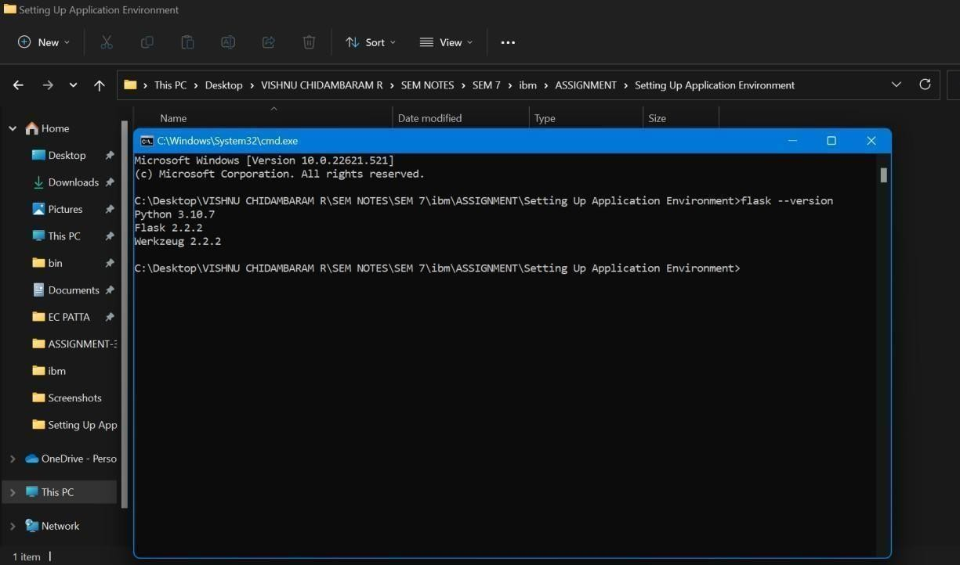

# Step 4:

Open Visual Studio Code and enter the code given below,

# from flask import Flask app

**= Flask ( name )**

# @app.route("/") def hello_world(): return "<p>Hello, World!</p>"

**Step 5:**

Save the code and give the file name as **app.py.**

# Step 6:

Go to the file location and open command prompt and type this command in

command prompt: ***Flask run***

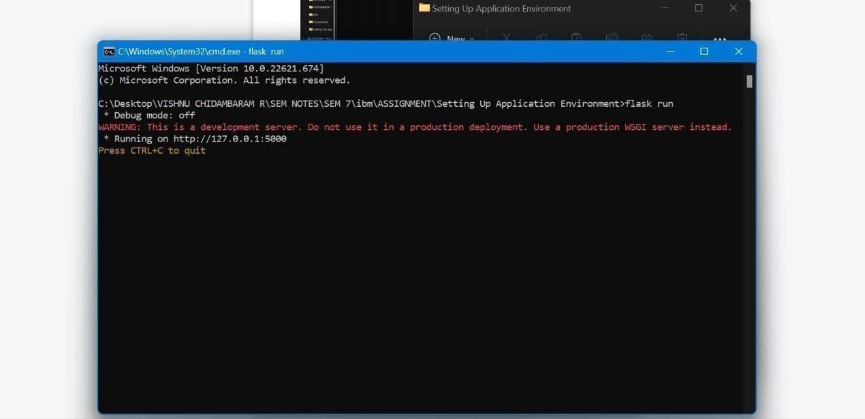

# Step 7:

Click the Link (or) Copy the address (http://127.0.0.1:5000) and put it, in the browser

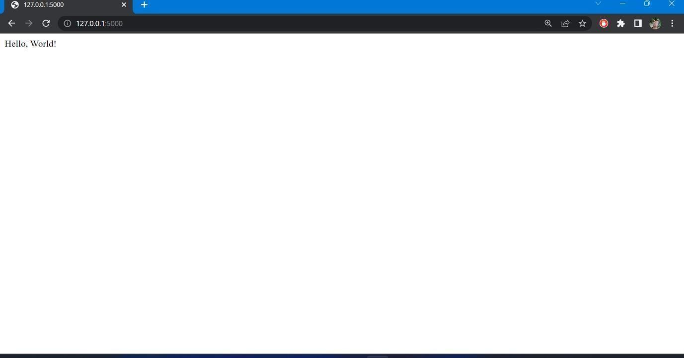and click enter. Then the Result will be same as the below screenshot:

# Step 8:

Now, you have successfully completed the process of creating simple flask project.